# Week 4 Assignment 1

Zach Adair

MSDS 600

11/12/2018

[zadair@regis.edu](mailto:zadair@regis.edu)

## R and R Studio in the menu section

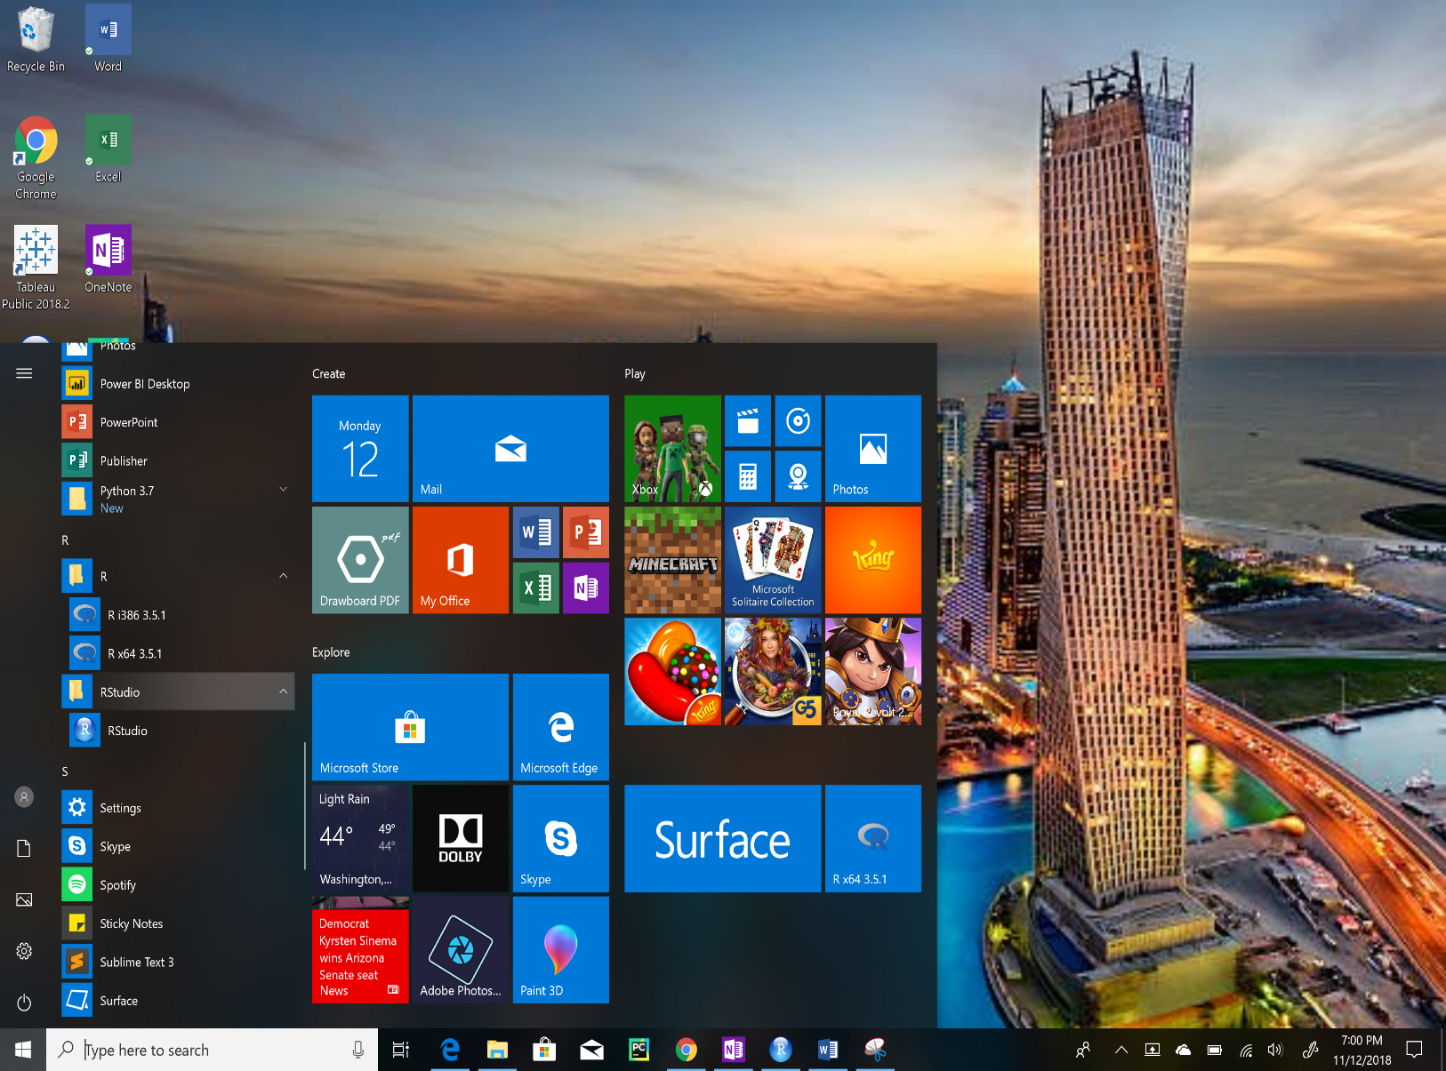

## R Studio on the Home Screen



## R Studio in its File Location

